Blinkit Data Project
Project Brief
- Blinkit deals as quick commerce company that runs the business across India, distributed in different states.
- With the increase in the number of daily orders in India. The company is planning to shift its traditional data management and analysis to a better tool.

Problem Statement:
As the business scales, the existing traditional methods of managing and analyzing inventory data have become inefficient, leading to challenges in stock tracking, damaged goods reporting, and supply chain decisions.
The company requires a modern, interactive, and real-time data visualization solution to:
- Track inventory stock levels across different locations.
- Analyze trends in stock received and damaged stock.
- Monitor product-level performance and stock movement over time.
- Enable decision-makers to act quickly based on data-driven insights.

Goal of the Project
The goal of this project is to build an interactive Power BI dashboard that helps the operations and supply chain teams to better understand inventory dynamics and make informed business decisions.

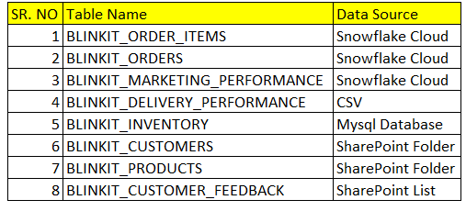
Data Sources:

- Note that the stakeholders wish to see the marketing performance data in real time.

Phase 2 – Pre-Report Building Step
Overview: -
- The following step of the project we need to consider the logics that are important for building the reports.
- In simple terms, the focus must be on the creations of different KPIs based on the requirements of the client.
- For example,
  - Total Number of Orders
  - Count of Delayed Orders
- These are some of the above KPIs mentioned.
- Once the KPIs are created the next step would be to prepare the reports.
- The client is considering four reports to be prepared.
  - Sales Performance Report (Summary Report)
  - Product Performance Report (Detailed Report)
  - Delivery Performance Report
  - Customer Feedback and Sentiment Analysis Report
  - Marketing Performance Report

Report Building Information: -
- Sales Performance Report (Summary Report)
  - This report provides a high-level overview of sales performance including revenue generation, order volume, and customer metrics. It's ideal for business stakeholders to track performance trends over time and across regions.
  - Expected KPIs
    - Total Orders
    - Total Revenue
    - Average Order Value
    - Unique Customers
    - Sales Over Time
  - Note the report must be able to give the overview of the data, give analysis based on filters such as date, payment methods,
- Product Performance Report
  - Product-level performance by showing top-selling products, categories, and brands. Helps identify which products drive revenue and where improvements are needed.
  - Expected KPIs
    - Total Products Sold
    - Total Product Revenue
    - Top Product = RANK(COLUMN, MEASURE())
    - Average Margin Percentage
  - The report must give us detailed Category distribution of products in terms of total number of orders.

- Delivery Performance Report
  - Evaluates delivery operations, highlighting the efficiency of delivery partners and the rate of timely deliveries. Also focuses on understanding delays and distances covered.
  - Expected KPIs
    - Total Deliveries
    - On-Time Deliveries
    - Late Deliveries
    - On-Time Delivery %
    - Average Delivery Time
    - Average Distance
  - The main objective of the report is to get the analysis of delivery time and cover all the aspects of it.

- Customer Feedback and Sentiment Analysis Report
  - Customer satisfaction using feedback data. Includes rating averages, sentiment trends, and common issues faced by customers.
  - Expected KPIs
    - Total Feedbacks
    - Average Rating
    - Positive Feedbacks
    - Negative Feedbacks
    - Positive Feedback %
  - The report must give us sentiment analysis, how is a person feedback based on the services used.

- Marketing Performance Report
  - Tracks the effectiveness of marketing campaigns through key performance indicators like impressions, clicks, conversions, and return on ad spend (ROAS).
  - Expected KPIs
    - Total Impressions
    - Total Clicks
    - Total Conversions
    - Click-Through Rate (CTR)
    - Conversion Rate
    - Total Revenue from Campaigns
    - Total Ad Spend
    - ROAS

